Amser Stori Blant Bach

Yn Llyfrgell Llay
Bob Dydd Mercher
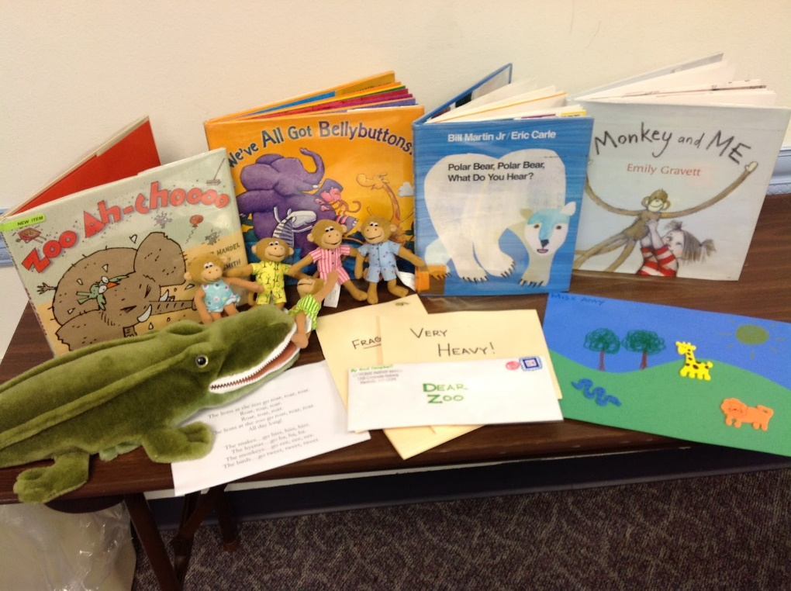
2.30 – 3.00 pm

Toddler Story Time
Toddler Story Time
at Llay Library
Every Wednesday
2.30 – 3.00 pm

